DW LIFESTYLE

Germans and their Christmas tree –

a true love story
In Germany a Christmas tree - a real one - is a must-have. Some people see it as a short term roommate and even give it a name. And the ritual of getting one is also part of the celebration.

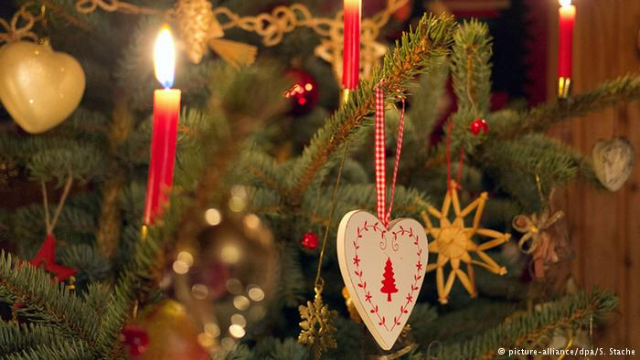
A Christmas tree is not just a Christmas tree. At least not for most Germans. An American, for example, can be found unpacking his artifical one from storage. But more than 25 million Germans celebrate the whole process of buying a "perfect" Christmas tree - with a generously open billfold. A meter-high (3.3-ft) tree costs between 18 and 24 euros ($19,50 - $26).
Some Christmas tree buyers will head off to Engelskirchen. The name of the town - literally "Angel's Churches" - already radiates a holy atmosphere. That's where Stefan Lüdenbach cultivates evergreens, a third-generation family business.

The popular organic seal

Stefan Lüdenbach knows what his customers want: organically grown Christmas trees. Weeks before Christmas, some will even reserve their organic tree with red-and-white streamers.
The tree grower has his own natural "angels" to guarantee that his trees are purely organic: "My 30 sheep - they replace the pesticides," he says and laughs.
Hans Dirlenbach and his son-in-law Rainer Pickert are looking for such a natural evergreen. "We try to focus our diet on organic food, so why should that not apply to our Christmas tree," says Rainer Pickert. They do not only want to buy an organic tree, they also intend to saw it personally.
A tree that's part of the family
Buying a Christmas tree can even develop into an event. Angus Sutherland, from the UK, and his German wife Myriam are enjoying steaming punch in front of the bonfire on the Lüdenbacher courtyard with their two small daughters Lucy and Romy. They're waiting for friends to join them to repeat last year's ritual: sawing together the "perfect" Christmas tree.
"We enjoy the atmosphere, besides it is entertaining for the girls and in the end, we all have a Christmas tree," says Angus, who didn't saw any Christmas trees in his family growing up Crewe, England.
"I have been growing Christmas trees for so long that I have seen many customers' kids grow up, too," says Stefan Lüdenbach.
Personalized tree - and service
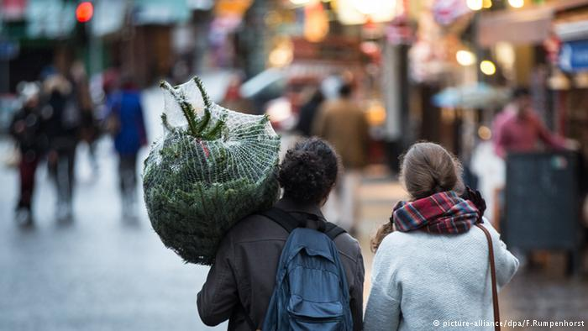
In the parish of St. Severin in Cologne, each Christmas tree carries its personal name tag. Following a more than a decade old tradition, all the evergreens to be sold are ceremonially baptized, marking the beginning of Advent and the start of the Christmas tree sale.

Don't be surprised if your Christmas tree is named Abraham, Blasius, Debora or Esther.

It is not uncommon either in Germany to support social groups by buying Christmas trees for charitable purposes - for example, buying one at the Rodenkirchen Volunteer Fire Brigade in Cologne. Every year, its youth department saws firs for their sale that begins precisely at 3:30 p.m. on the last Friday before Christmas.
The residents of Rodenkirchen and maybe some Christmas-tree-event-tourists from other towns will line up waiting for the gate to open. Rain, snow, or icy temperatures don't diminish the devoted loyalty of the customers who seek to support their local youth department.
The experience itself is heartwarming. Once the gate opens, a bunch of teenagers dressed in their uniforms and donned with red-and-white Santa-Claus caps move forward welcoming their customers with a polite "May I help you?"
'Larger? Maybe bushier?'
Every year, the teenagers patiently help their customers find the "perfect" tree. "We have our regular customers," says Yannik Breuer, who heads the youth department and manns the show with the same passionate dedication as his youngsters. "They enjoy our tradition, but they also seek to support our work with the younger generation and they are happy to pay generously."
After the customer finds the right tree, the youth's work is not finished yet. The teenagers will be seen accompanying their customers by dragging the evergreens to the many queues: standing in line to have the tree cut, to have the tree wrapped in a net for safe transportation and finally holding the tree patiently at the cash register where firefighters of the adult generation note if the customer wishes for a personal delivery.

The picture perfect tree

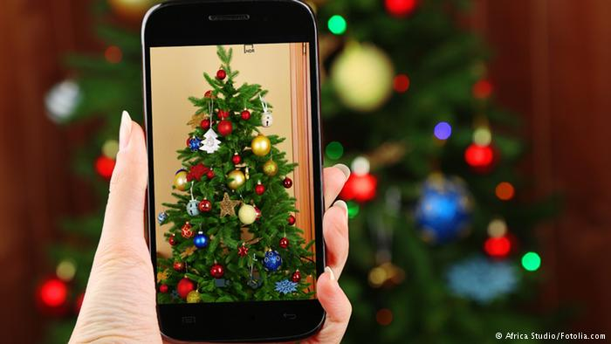
As the last Advent weekend progresses towards Christmas Eve, some of these delivered trees will spend their last days before getting decorated on a balcony, in a garden or a garage: Many German families follow tradition and wait until Christmas Eve to put up their trees.

That's when that "perfect" tree will be glowing a living room, maybe the traditional way, with red - and real - candles, or dressed in electric lights and flashy lametta.

