How Hedy Lamarr Invented Early Wireless Technology
Karli Petrovic (IQ Intel Blog)
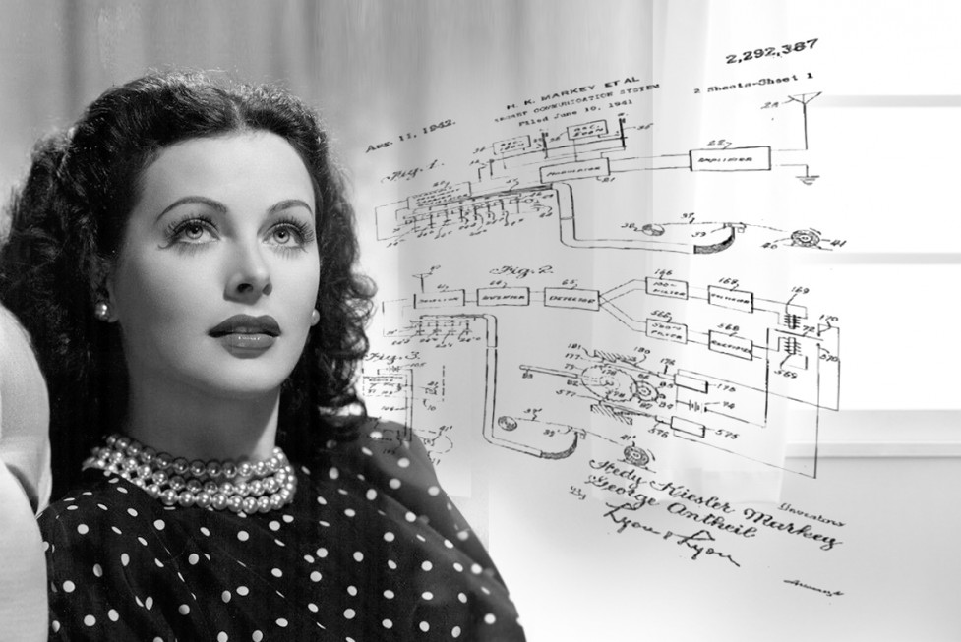

A lonely immigrant from Austria slips out of her stage clothes and kicks off her heels. Carefully removing her movie makeup, she’s dissatisfied that she’s been overlooked for more significant roles. Instead of throwing a pity party over a glass of Pinot Noir, however, she heads determinedly for her drafting table, a place where she’s previously invented an improved traffic stoplight.
This is where she’ll prove to the world that she’s more than a pretty face.
The scene sounds like Oscar-bait, but the truth is much more fascinating. This is the real-life story of Hedy Lamarr, Hollywood actress turned tech hero.
An inventor whose contributions were recognized posthumously by the National Inventor’s Hall of Fame in 2014, Lamarr helped develop a system used in Bluetooth, GPS and Wi-Fi.
Her dual life as an actress and innovator was part of what makes Lamarr such a captivating character. This was perfectly captured in Google doodler Jennifer Holm’s nod to Lamarr on what would have been her 101st birthday.
“Lamarr has kind of a mythical status at Google, and I was pretty excited at the chance to tell her story in doodle form,” Holm wrote about her doodle. “Sketching storyboards on a yellow notepad helped me figure out how to show Lamarr in very different scenarios — movie star by day, inventor by night.”
Brains Before Beauty
Although Lamarr was a Hollywood glamour girl and played the femme fatal in movies opposite the likes of Clark Gable and Spencer Tracy, she wasn’t the typical looks-obsessed starlet.
“Any girl can be glamorous,” she once said. “All you have to do is stand still and look stupid.”
As Pulitzer Prize-winning author Richard Rhodes indicated in his book Hedy’s Folly: The Life and Breakthrough Inventions of Hedy Lamarr, The Most Beautiful Woman in the World, Lamarr’s idea of a good time was a dinner party and discussion with intelligent friends.
“Hedy didn’t drink. She didn’t like to party,” Rhodes told NPR. “Hedy had to find something else to do to occupy her time.”
That “something else” was inventing, and it turned out she had a knack for designing problem-solving technologies. Transforming the drawing room in her house into an innovation studio with a drafting table and the necessary tools, Lamarr invented an aid to help people with limited mobility get in and out of the bath, a florescent dog collar and a bouillon cube that would dissolve to turn water into soda.
While Rhodes said Lamarr laughed that the latter invention was a complete flop, her best-known success was a passion project that still has applications today. The “secret communication system” she developed with composer George Antheil, a neighbor and friend, was the precursor to today’s top wireless technologies.
“Though invented for a different purpose, the fundamentals of the concepts for frequency hopping became a foundation for widely used wireless technologies we readily use today,” said Aicha Evans, Vice President and General Manager for the Intel Communication and Devices Group.
“In the end, wireless is about dividing up the air into clear data transport lanes, modulating and moving data around in a predictable and accurate manner,” she said.
Evans said Lamarr and Antheil’s particular method of efficiently guiding and transporting data over the air was “pure genius” and the foundation for future advancements in wireless technology.
Live and Learn
Born Hedwig Eva Maria Kiesler, Lamarr hailed from Vienna and was of Ukrainian-Hungarian Jewish heritage. Her first marriage was to a munitions manufacturer named Friedrich Mandle, who reportedly conducted business with Benito Mussolini and hosted Adolf Hitler at the couple’s home. Mandle also taught Lamarr about military technology, something that would come in handy years later.
As her marriage to Mandle became increasingly suffocating and abusive, reported CNN, Lamar escaped to America, cleverly booking her voyage so that it coincided with Metro-Goldwyn-Mayer (MGM) studios’ Louis Mayer.
According to Rhodes, Mayer initially offered Lamarr an acting contract when she met with him in London on another occasion but wasn’t satisfied with his terms and confidently walked out on the deal.
That changed rather quickly when the two became traveling companions.
“Once she was aboard, she found a way to make him long for her — after all, she was an actress,” Rhodes told NPR. “And before the ship landed in New York, she had a much, much better contract — the equivalent of about $3,000 a week for seven years.”
Despite securing superstar status in the industry, Lamarr’s fascination with science and technology never faltered. She set her sights on helping the Allies in World War II.
When many German submarines began targeting non-military ships, Lamarr believed radio-guided torpedoes would make more powerful and accurate retaliatory weapons for the Allies’ cause, but she needed to find a way to prevent the radio signals from jamming.
Lamarr and Antheil developed a radio communication system based on the 88 piano keys. It was a success, and the duo received a patent for their work in 1942. Unfortunately, the U.S. Navy ignored their technological feat for another 20 years.
Gone But Not Forgotten
When the war ended, Lamarr and Antheil’s work could have easily perished in a Navy file cabinet. Instead, their invention helped military and private companies develop a frequency-hopping mechanism used during the Cuban Missile Crisis. Later, the system became the precursor to modern wireless technologies.
Although Lamarr didn’t help the Allies as she’d planned, she understood that sometimes things need to move slowly.
“The world isn’t getting any easier. With all these new inventions I believe that people are hurried more and pushed more,” she once said. “The hurried way is not the right way; you need time for everything – time to work, time to play, time to rest.”
Lamarr’s work remained unrecognized until 1997, when the Electronic Frontier Foundation acknowledged “spread-spectrum broadcasting” for its ability to give “give ordinary people with ordinary resources” affordable access to the airwaves.
“The special award for Lamarr and Antheil is remarkable for other reasons besides its recognition of a woman whose contributions were thought to be solely in the field of entertainment,” said EFF Staff Counsel Mike Godwin in the press release. “Ironically, this tool they developed to defend democracy half a century ago promises to extend democracy in the 21st century.”
Intel’s Evans believes new advances in wireless technologies are truly democratizing the Internet, making access easier for people all over the globe.
“Mobile technology is becoming a core element of humanity,” said Evans, who is currently working on bringing 5G wireless technology to the masses. “It’s about the problems and opportunities in our global community.”
This was also true in Lamarr’s time when frequency jumping offered an opportunity to give the Allies an advantage during the war. While Lamarr likely didn’t know the extent to which her invention would impact the world, she knew it was significant enough to warrant recognition.
So what happened when Lamarr heard the EFF was giving her an award? At the time, three years before her death in 2000, the 86-year-old responded with characteristic confidence.
“When they called her up to tell her she would get the award,” Rhodes said, “her first words were, Hedy Lamarr being Hedy Lamarr, ‘Well, it’s about time.'”

