Lebkuchenherzen Redewendungen (Gingerbread heart phrases)
You’re going to make your own Lebkuchenherzen (gingerbread heart) out of paper! Below, you’ll find some phrases to choose from. If you’d rather make up your own phrase, please OK it with Frau. Your Lebkuchenherz must be neatly colored and that the phrase can be easily read in your neatest handwriting (no pencil!). Your heart is worth 15 points, deductions will be made for misspellings and messiness.
Viel Glück und viel Spass!! (Good luck and have fun!)
- Oktoberfest 2016
- Ich liebe Oktoberfest! // Ich Oktoberfest!
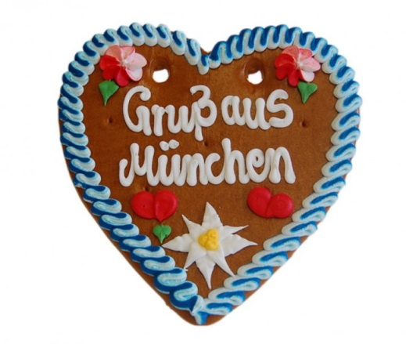
- O’Zapft is! = It’s tapped!
- Gruß aus München = Greetings from Munich
- Gruß vom Oktoberfest = Hello from the Oktoberfest
- Herzlichen Glückwunsch und alles Liebe = Congrats & all the best!
- Ich liebe Dich = I love you
- Ich hab Dich (sooo) lieb = I like you (sooo) much
- Ich mag Dich = I like you
- I mog Di = I like you - in Munich dialect
- Glückspilz = lucky mushroom!
- Spatzl = little sparrow
- Für Dich = for you
- Für mein Mädl = for my girl
- Für meinen Freund (Freundin) = for my boyfriend (girlfriend)
- Drücke mich = hug me
- Meiner Kuschelmaus = my snuggle-mouse
- #1 Mutti, Vati, Oma, Tante, usw. = #1 mom, dad, grandma, aunt, etc.)
- Mein Schatz = My treasure (sweetheart)
Lebkuchenherzen Redewendungen (Gingerbread heart phrases)
You’re going to make your own Lebkuchenherzen (gingerbread heart) out of paper! Below, you’ll find some phrases to choose from. If you’d rather make up your own phrase, please OK it with Frau. Your Lebkuchenherz must be neatly colored and that the phrase can be easily read in your neatest handwriting (no pencil!). Your heart is worth 15 points, deductions will be made for misspellings and messiness.
Viel Glück und viel Spass!! (Good luck and have fun!)
- Oktoberfest 2016
- Ich liebe Oktoberfest! // Ich Oktoberfest!
- O’Zapft is! = It’s tapped!
- Gruß aus München = Greetings from Munich
- Gruß vom Oktoberfest = Hello from the Oktoberfest
- Herzlichen Glückwunsch und alles Liebe = Congrats & all the best!
- Ich liebe Dich = I love you
- Ich hab Dich (sooo) lieb = I like you (sooo) much
- Ich mag Dich = I like you
- I mog Di = I like you - in Munich dialect
- Glückspilz = lucky mushroom!
- Spatzl = little sparrow
- Für Dich = for you
- Für mein Mädl = for my girl
- Für meinen Freund (Freundin) = for my boyfriend (girlfriend)
- Drücke mich = hug me
- Meiner Kuschelmaus = my snuggle-mouse
- #1 Mutti, Vati, Oma, Tante, usw. = #1 mom, dad, grandma, aunt, etc.)
- Mein Schatz = My treasure (sweetheart)

