Name: __________________________________ Datum: _____________________ Stunde: ______
Nordwand – Ein Tagebuch
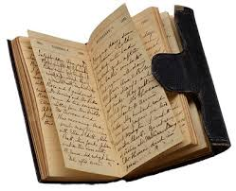
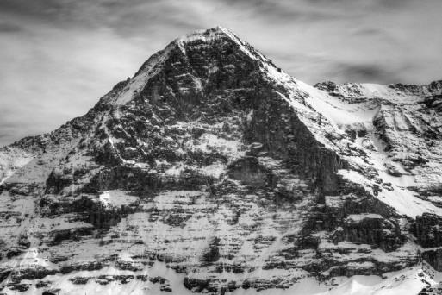

You will be writing a diary from the perspective of a character of the film Nordwand. You may choose any main character: Toni, Andi, Louise, one of the Austrians, the Swiss man in the mountain, or Henry Arau, the head reporter. You diary should include at least five (5) entries. Two should be dated before the ascent begins, two should be during, and one should be afterward. (If you choose to write from the perspective of a climber, you should write three entries during your ascent.) Each entry should include at least 6 sentences, and should be written in the past tense.

I will look for:
- correct use of the Perfect past tense
- word order, spelling
- correct cases (watch out for prepositions, direct/indirect objects!)
- USE WHAT YOU KNOW! DO NOT USE ONLINE TRANSLATORS! I can tell when you use an online translator. You will be severely marked down for this.
- concrete examples and mention of scenes / moments in the film. You will have to take notes during our viewing in order to do this.
- creativity and insight. (pictures are welcomed!)
- diary format with dates – typed and printed

Your diary is due: ____________________________________________________________________

