11 March 2014

Stefan Zweig: Grand Budapest Hotel’s inspiration
Matthew Anderson
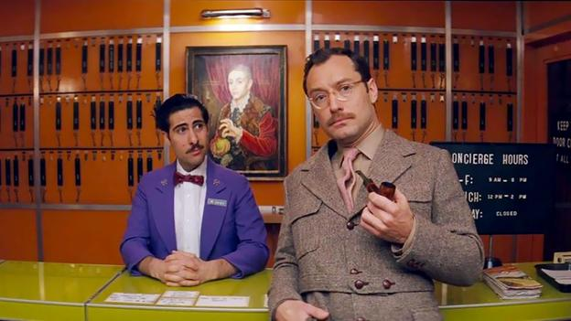

Jason Schwartzman and Jude Law in The Grand Budapest Hotel (Fox Searchlight)
Stefan Zweig was once ‘the world’s most translated author’ – then he faded into obscurity in the English-speaking world. But a revival in interest is under way, reports Matthew Anderson.
Grand Budapest Hotel’s dark side

A few years ago the director Wes Anderson was browsing the shelves of a bookshop in his adopted home of Paris when he made a chance discovery. He took down a copy of Beware of Pity, a 1939 novel by the Austrian writer Stefan Zweig, recently re-released in English after years out of print. “I think I read the first page in the store and thought, ‘OK, this is a new favourite writer of mine,’” Anderson told Variety.
It’s not surprising that Wes Anderson took so long to find Zweig, who until recently was almost forgotten in the English-speaking world. At the Strand Book Store in New York City (motto: “18 miles of books!”), there are currently just eight titles in stock. But in Dussmann, Berlin’s vast ‘cultural department store’, Zweig’s many works have a shelf all to themselves. In France, they have never been out of print. Until Pushkin Press and the New York Review of Books began to re-issue new editions in recent years, Zweig was known outside continental Europe by just a small group of literary aficionados and students in university German departments.
Zweig’s fall from fame is remarkable given he was regularly billed as ‘the world’s most translated author’ throughout the 1920s and ‘30s. His pacy novellas and vivid psychological biographies were international best-sellers, devoured by fans from London to Buenos Aires. His speaking engagements drew huge audiences and he could sell out New York’s Carnegie Hall. He spoke regularly on the radio and was interviewed by the BBC in an early experiment with television in the ‘30s. An avowed cosmopolitan, Zweig travelled extensively and knew all the major intellectual and artistic figures of the time, corresponding with Einstein and giving the eulogy at the funeral of Sigmund Freud.
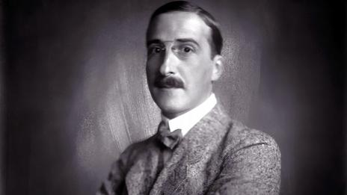
Zweig in 1920 (Imagno/Getty Images)
“He was one of the first star authors, and even in an age with no TV and very few pictures in the newspapers, people recognised him wherever he went,” says Zweig’s biographer Oliver Matuschek, who has spent 20 years researching the writer’s life and works. “The sheer volume is unbelievable,” says Matuschek. “In the collected works in German there are 36 volumes, and that doesn’t include the 500 pieces of journalism that were published in newspapers and magazines in his lifetime.”
Be my guest
In many ways Zweig, the urbane man of letters who collected manuscripts by Goethe and owned Beethoven’s desk, symbolises an idea of European sophistication that vanished with the Nazis’ rise to power. He was born into a wealthy Jewish family in Vienna in 1881 and his privileged background meant he could devote himself to writing without worrying about money. His popularity made him richer still and as his fame grew, he travelled widely to lecture and promote his books, staying in opulent hotels all over Europe. It is little wonder that so many of his stories play out in grand guesthouses.
“The hotel is the best stage you could invent for a writer like Zweig,” says Matuschek. “There are all sorts of people there, from very grand guests to humble members of staff. And of course many of the people who read his books would never have stayed in a five-star hotel. But they would have had their own ideas and used their imagination to create this world.”
In The Post-Office Girl, a lowly postal clerk in Austria after World War I receives an invitation to an Alpine resort, where she is intoxicated by the grand surroundings. She dresses up in fine clothes and affects the manners of the hotel’s guests – but is sent packing in disgrace when her humble background is exposed. Zweig’s 1927 novella 24 Hours in the Life of a Woman also revolves around a scandal in luxury lodgings, and like The Grand Budapest hotel, it is narrated as a story within a story, one of Zweig’s favourite devices. Wes Anderson has borrowed from both works and from Zweig’s contemporary Thomas Mann, whose rakish title character in The Confessions of Felix Krull rises from the modest station of lift-boy in a grand Parisian establishment by charming and seducing the wealthy guests.

Zweig for beginners

Where to start in the Austrian author's oeuvre
Beware of Pity
An ambitious young cavalry officer befriends a millionaire aristocrat and attracts the amorous attention of his crippled daughter, with terrible consequences.
The Post-Office Girl
A humble postal clerk travels to a plush Alpine hotel as the guest of her aunt, where she is seduced by the glittering world of the upper-middle class.
Chess
On a steam liner bound for Argentina, an epic game between a mysterious stranger and the reigning world chess champion reveals a terrible story of persecution and madness.
When the credits roll at the end of Anderson’s latest film, The Grand Budapest Hotel, the first one goes to Stefan Zweig, whose writings inspired it. “It’s basically plagiarism,” the director joked at a press conference before the film’s premiere at the Berlin Film Festival. But it is actually a fantasia on themes from Zweig’s life and works, a homage to the writer and his refined vision of Europe before World War II.

Gone but not forgotten
The Grand Budapest Hotel builds to a rollicking finale, but there is an air of sadness that mirrors the sudden and tragic end to Zweig’s life. Just a week after the fall of Singapore, at the height of World War II, newspapers across the world cleared room to report the news of his death. Many found space on the front page. His last years were lived in exile in Britain, the US and finally Brazil. Zweig read the writing on the wall with the rise of National Socialism and fled his home in Salzburg in 1934 before his beloved Austria was annexed by the German Reich. His books were banned and burned, and his citizenship revoked.
On the evening of 22 February 1942, Zweig and his second wife took a massive dose of barbiturates and lay down next to each other on their bed in Petrópolis near Rio de Janeiro. “The world of my own language sank and was lost to me,” he wrote in his suicide note, “and my spiritual homeland Europe destroyed itself.”
Zweig’s slide into obscurity in the English-speaking world began shortly afterwards. Why did this happen? “His books are very much products of pre-war Europe,” says Adam Freudenheim, publisher and managing director of Pushkin Press. “They probably didn't resonate very much in the 1940s to the ‘60s.” Another reason for his recent obscurity is the reluctance of readers in the US and UK to read literature in translation. Studies in both countries suggest that these books make up only 3-4% of total sales. And the quality of the previous translations – rendered in leaden, heavy-going prose – was also undoubtedly to blame. “It's generally a good idea to have books re-translated every few decades,” says Freudenheim. “It does seem to be the case that languages – at least English – change enough that older translations can sometimes, perhaps often, feel stale.”
Wes Anderson’s new film is a new translation of sorts. He has boiled Zweig’s life and works down to their marrow, and re-imagined them in his unique cinematic language. As artists, the two couldn’t be more different. Zweig’s works are serious, restless and psychological and they have the stiffly formal quality of his times. Wes Anderson’s films are witty, cool and ironic, more concerned with surfaces than interiors. But despite its frothy tone and galloping pace, The Grand Budapest Hotel is a kind of monument – it begins, after all, in mock-sombre fashion with a teenage fan’s pilgrimage to the statue of a great author. Wes Anderson’s massive enthusiasm for his “new favourite writer” is there in every frame, and will turn a whole new audience on to a wonderful author we almost forgot.

