The Nutcracker – A Symbol of Christmas
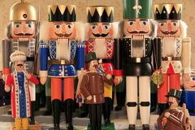

Nutcrackers and Räuchermännchen (Smoking Men) from the Erzgebirge.

Nutcrackers in various shapes and sizes have been around for thousands of years, the nutcracker soldier known the world over – and immortalized by Tchaikovsky – is of German origin, as is the story on which the popular ballet is based.
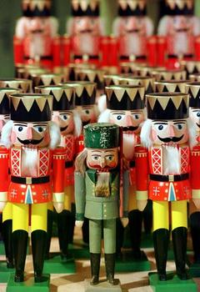
The traditional toy soldier nutcracker comes from the Erzgebirge, or Ore Mountains, in the Free State of Saxony along the Czech-German border. Villages here developed alongside a booming mining industry after mineral resources were discovered in the mid-12th century. The miners in these villages would carve and whittle in their spare time, making toys and small items which they sold to peddlers. After the mining industry declined in the 17th century, these inventive craftsmen perfected their handicraft in order to earn their livelihoods.

Flanked by colorful, new king nutcrackers, the 150-year-old forester, made by Wilhelm Friedrich Füchtner, is considered the oldest turned nutcracker.

One classic nutcracker is still made today after the 1870s original by Wilhelm Friedrich Füchtner of Seiffen, a picturesque town in the Erzgebirge well-known for its talented toymaking citizens. Known as the “father of the nutcracker,” Füchtner launched the first commercial production of these wooden figures, turning the figures on a lathe instead of whittling them by hand. Nevertheless, this improved method of production is still quite labor-intensive. The creation of one nutcracker requires more than 100 steps, and it is assembled from about 60 individual pieces, before the finishing touches – fur, leather, and cords – are added.
Traditional forms for the nutcrackers from the Erzgebirge at this time were figures of authority: soldiers, kings, policemen, and foresters. Whether or not they can be seen as caricatures or figures of social satire, it’s certainly not hard to imagine that the miners would have enjoyed letting the king crack open a few nuts for them. And of course, some nutcrackers also resemble miners, who are depicted with a crossed hammer and chisel on their hats.
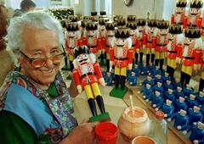
The family-run Füchtner Workshop, now in its sixth generation, continues the traditional production of the nutcrackers created in the 1870s

Over the years, the nutcracker also took on new forms of identity. German Chancellors and American Presidents as well as St. Nikolaus and representations of a variety of occupations became popular. Thanks in part to their immense worldwide popularity, however, the traditional craft techniques and styles developed in the Erzgebirge, which includes the woodturning of not only these nutcrackers but also Reifendrehen (carving toy animals from wooden hoops) and Spanbäumchen-Stechen (carving wooden trees with intricate, curly branches), among others, are still continued and cherished today.
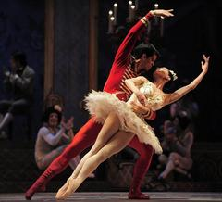
The German nutcracker became widely popular in the US in the 1950s. This was due in part to the American soldiers stationed in Germany who brought nutcrackers back as gifts as well as to the immense popularity of the ballet The Nutcracker during that time.

Interpretations of Tchaikovsky's "The Nutcracker" are performed all over the world.

The ballet The Nutcracker is based on the story Der Nussknacker und der Mauskönig (The Nutcracker and the Mouse King), which was written by German author E.T.A. Hoffmann and published in 1816. This dark fairytale follows a young girl’s fantasy in a world of fairies and princes, where toy soldiers battle an army of mice.
Ernst Theodor William Hoffmann (1776-1822), better known by his pseudonym E.T.A. Hoffmann, wrote operas and composed a number of musical scores, before devoting himself to writing fiction. One of the great writers of the German romantic literary movement, he gained popularity for novels and collections of short stories. His works, which range from the fantastical to the grotesque, are said to have influenced a great number of important 19th-century writers and composers.
In 1891-92, Russian composer Pyotr Ilyich Tchaikovsky composed the music for the ballet The Nutcracker, which was staged by Marius Petipa. It was based on a revision of E.T.A. Hoffmann’s story, an adaption written by the French author Alexandre Dumas père that was titled L’Histoire d’un Casse Noisette (The Story of a Hazelnut-Cracker). In this version, a number of changes were made. The events that take place are no longer a dream sequence, for example, and the heroine ends up marrying the Nutcracker prince.
A selection of the ballet, peformed as The Nutcracker Suite, gained immediate popularity, but the ballet in its entirety did not become widely performed until the mid-1950s. The San Francisco Ballet debuted The Nutcracker in the US in 1944. It is choreographer George Ballanchine’s 1954 production by the New York City Ballet, however, which is credited for making The Nutcracker a perennial Christmas favorite among generations of audiences in the US.

© Germany.info

