A Growing Challenge for Germans Who Live by Bread Alone
By MELISSA EDDY JUNE 3, 2014
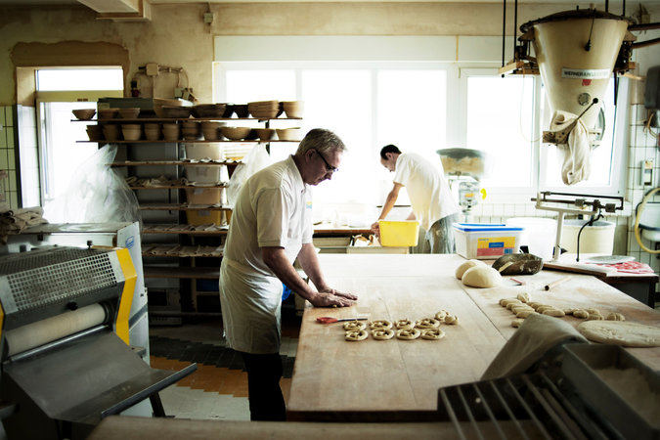
Fritz Trefzger, a baker in Schopfheim, Germany, has opened his kitchen to the public to attract customers and send a message to those tempted to buy their breads at the supermarket. Credit Daniel Auf der Mauer for The New York Times

SCHOPFHEIM, Germany — On Sunday mornings, the line at the backdoor of Fritz Trefzger’s bakery snakes through the courtyard as customers wait for their chance to step into the inner sanctum of his kitchen.
Once there, they can pick his small, oblong white bread rolls, and their darker, seeded cousins, fresh off the oven racks. Just as important for the master baker, they can also watch him twist a rich, brown-crusted pretzel to perfection — thick in the lower belly, with arms thin enough to drape neatly on either side — with a few deft turns of his wrist.
That was the point, he said, of opening his kitchen to the public, something not normally done at traditional German bakeries. The idea was not only to attract customers, but also to send a message to anyone who might be tempted to pick up their Sunday rolls at the local supermarket, which have made the traditional German bakery an endangered species.
“I wanted them to see for themselves, up close, what we do,” said Mr. Trefzger, 58, as he sat in the cafe attached to the bakery that he took over from his father in 1989. “It is important that people learn to appreciate the traditional craft of baking bread.”
For now, it seems, they have all but forgotten. Industrial-scale baking and advanced freezing technology have made it possible for mass-produced loaves, rolls and pastries to be frozen and shipped around the country to supermarkets, where they can be heated up and sold for a fraction of the price of a hand-thrown equivalent from a traditional bakery.
The shift in culture is so worrying to bakers like Mr. Trefzger that they are taking extraordinary steps to raise the awareness of Germans, and the world, to the uniqueness of their threatened baking traditions. They are reaching out to young people via social media in an effort to attract more of them to the job. Last year, the German Bakers’ Association even applied for the country’s baking tradition to receive special recognition and protection by adding it to the Unesco list of cultural heritages, where it would gain a spot alongside French cuisine and Croatian gingerbread.
So far, however, none of those steps has reversed the seemingly inexorable decline of the German bakery. Last year, the number of German bakeries dropped 3.6 percent. Only 13,171 now remain in a country of about 80 million people that six decades ago counted more than 55,000 bakeries in the former West Germany alone. In the past seven years, the number of young people training to become bakers has dropped by a third, to 26,535 in 2013.
That is a long fall for German culinary tradition, more commonly associated with sausages, sauerkraut and potatoes. Yet from the days of Charlemagne until the end of the previous century, a staple of the German diet was thick, hearty slices of sourdough-leavened bread made from grains like rye or spelt. The German word for supper, “abendbrot,” means “evening bread.”
“Until the 1960s, bread served as the central source of nourishment in Germany,” said Peter Becker, president of the German Bakers’ Association. “People would even make a cross on the bread as a sign of thankfulness. That significance has been lost.”
Like many traditional bakers, Mr. Trefzger came to his profession through his father, who instilled in his son the passion for his craft. But, Mr. Trefzger said, many parents no longer want to see their children enter a profession with such grueling hours — craft bakers usually begin mixing dough for the next day’s bread just after midnight — often discouraging even those who show an interest in baking.
Then there is the convenience of modern, mass-scale food production, which has enticed Germans as it has people in other industrialized countries. It can be hard to compete with.
Siegfried Brenneis, 48, a certified baker and pastry chef from the village of Mudau and a member of an elite group of German bakers who take part in international competitions, said supermarket bakeries had allowed discounters to attract customers through what he called “aroma marketing,” the pretense of handcrafted breads and pastries, even though the goods are not really made on the premises.
Comparing the situation to that in neighboring France, where a decline in baguette consumption has also caused concern, Mr. Brenneis lamented that Germans, too, had failed to appreciate the cultural importance of their bread, which includes 3,000 varieties, many specific to certain regions.
Schopfheim, nestled in the lush hills of the Black Forest, stands out as an exception. For a town of just 19,000 residents, it has an unusual density of traditional bakeries. Yet farther down the Wiese River, the neighboring city of Lörrach has twice as many inhabitants, but only one traditional bakery.
The difference can be credited to bakers like Mr. Trefzger, who is on a one-man campaign to elevate the profile of his craft. On any given Sunday, he will sell 200 to 300 of the rolls that in various corners of the country are called “wecken,” “schrippen,” or most commonly, “brötchen” — which translates as “little breads” — a staple of the extended Sunday breakfasts beloved by Germans.
He also hosts three trainees, who take classes at the regional vocational school to earn certification through Germany’s acclaimed dual-training system, which lasts two to three years.
Mr. Becker, the head of the national Bakers’ Association, said similar efforts had already helped raise the profile of bread, even if they had yet to arrest the decline in the numbers of German bakeries. The association also plans to make a reality television show that will take viewers into bakers’ kitchens across the country in an effort to find Germany’s best baker.
Some of the most promising ideas, however, have come from the newest generation of bakers, like Jörg Schmid, 29, and Johannes Hirth, 28. The pair have created films of what they call extreme baking, which include stunts like baking in a converted pickup truck mounted with a couple of beer tables and an oven into a kitchen-on-the-go. They run a series of courses, like Bread Baking 2.0 or Finger Food Reloaded,at their home bakeries, which have attracted hundreds of participants.
“It shows that people are interested in baking,” Mr. Hirth said, adding that he did not view teaching people to bake as a threat to his business. “Those who want to bake at home will always do so anyway, and it still raises the interest in bread.”
Not everyone, of course, is concerned with a bakers’ revival. Caspar Oehlschlägel, who lives down the road from one of the oldest bakeries in Berlin, said that since his local supermarket started offering whole-meal bread baked in the store, it was all he ever bought.
“Honestly, it’s the best bread that I have ever had,” Mr. Oehlschlägel said. “Just because it is industrial-made bread doesn’t mean that it is bad. Making bread by hand is fine, but it is really something for romantics.”

A version of this article appears in print on June 4, 2014, on page A7 of the New York edition with the headline: A Growing Challenge for Germans Who Live by Bread Alone.

