Where do we exchange to?
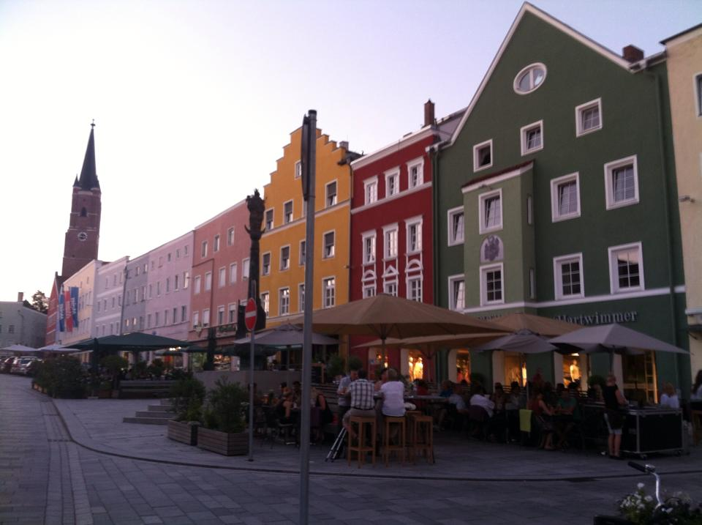
Enumclaw GAPP has had a very successful partnership with the Carl-von-Closen Gymnasium (high school) in Eggenfelden, Bavaira for many years now. The town is similar in size to Enumclaw and about an hour away from Munich, Germany, by train or car.

The main city square in downtown
Eggenfelden, Germany, July 2015

How long are we gone for?
Enumclaw GAPP leaves for their trip right after school lets out in June. We are required to be at school in Germany for 3 weeks, but will usually also take a longer “field trip” before or after our time at school. The usualy trip length is about one month.
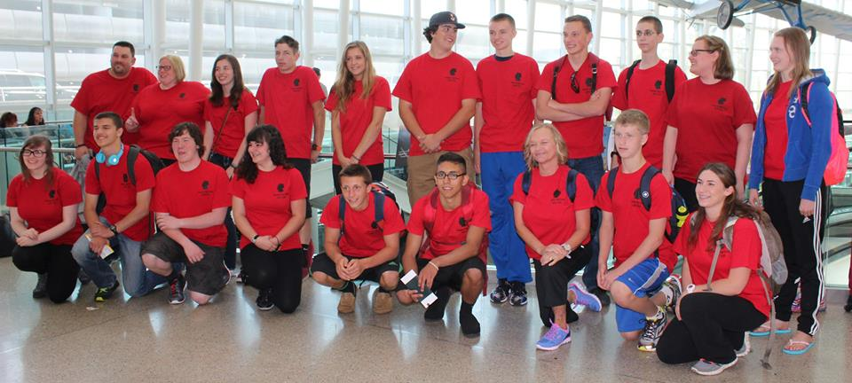

For more information about the Enumclaw High School GAPP exchange trip, please:
- Talk with Frau Holmquist!

Email: alysha_holmquist@enumclaw.wednet.edu

- Visit Frau Holmquist’s website:
www.frauholmquist.weebly.com
(and click on GAPP Exchange Trip tab)

- Visit the official GAPP website:
https://www.goethe.de/ins/us/en/sta/ney/lhr/gap.html

- Talk with previous GAPP’ers! See Frau or check out the bulliten board outside Room 140 to see if you recognize someone! Enumclaw High School German Exchange Trip

Join us in Germany –
Summer 2019!
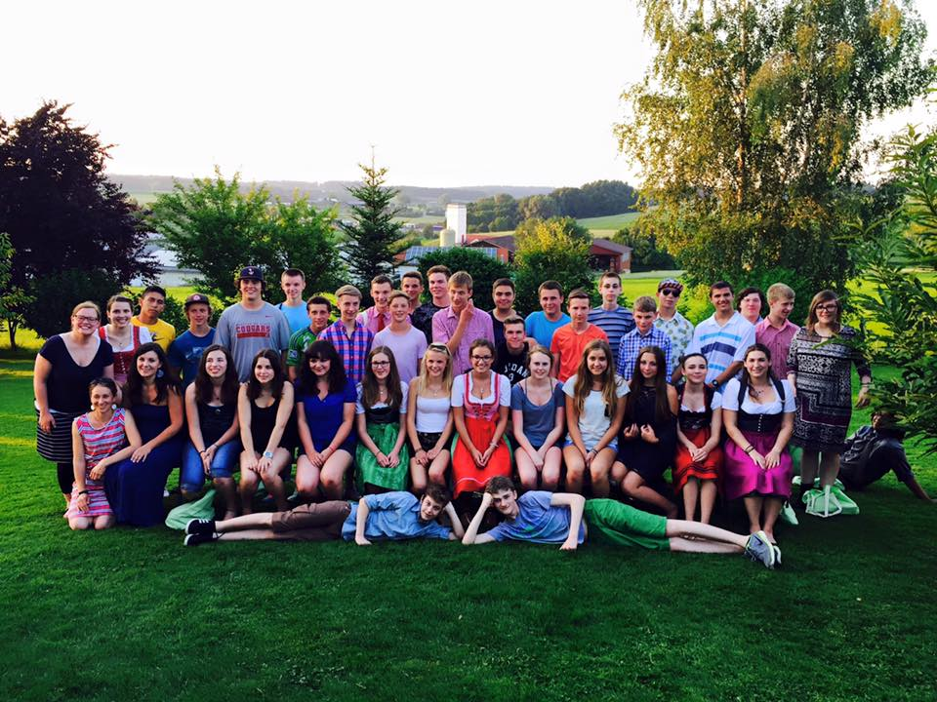

EHS GAPP students and their German partners in Eggenfelden, Germany, July 2015

EHS GAPP Coordinator:
Alysha Holmquist
EHS German Teacher
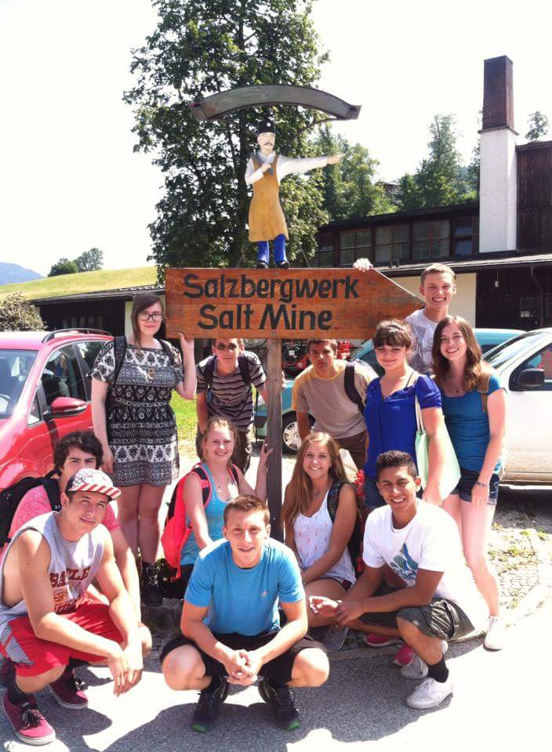

GAPP 2015 students at the Salzburg Salt Mine tour – an included field trip.

Where have previous GAPP trips visited while abroad?
Besides the standard field-trips to Munich, Neuschwanstein Castle, Salzburg, and Passau, GAPP 2015 toured eastern Europe:
- Berlin, Germany
- Prague, Czech Republic
- Krakow, Poland,
- Budapest, Hungary
- Vienna, Austria
Other groups have previously gone to:
- Italy
- France
- Switzerland
Will I get to choose my own partner?
Each student will fill out a detailed survey so that the American and German teachers can best match students together. We have a VERY high success rate!
Will I understand German school?
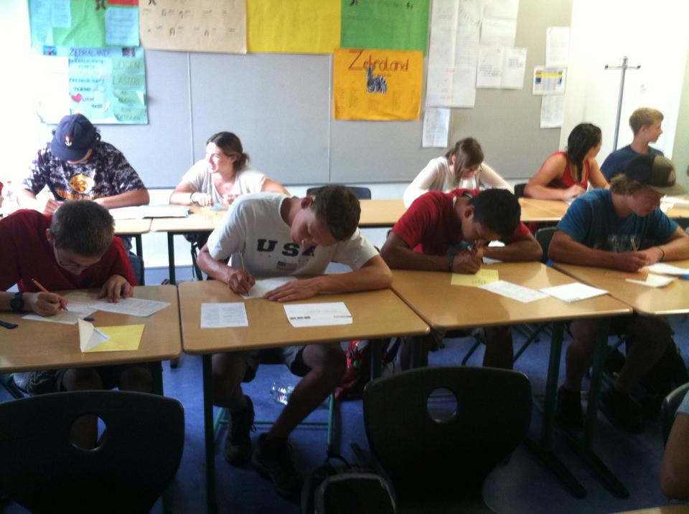
Yes! We will have homeroom every day together and then you’ll either spend the day shadowing a German student, on your own schedule, or out on a field trip!

GAPP 2015 students during Homeroom.
Will I get to talk to my parents & friends at home?
Yes! There are many ways to stay in touch with those back home: email, interntaional texting/calling, or apps like skype or whatsapp!
How much does GAPP cost?
GAPP can cost anywhere between $2500 - $3500 depending on plane tickets, insurance costs, hotel prices, etc. The exact cost will be announced closer to the departure date. But what a great price for one whole month abroad! And remember, while living with your German host family, your housing and food will be taken care of!
What can I do to help pay for GAPP?
There are multiple fundraisers throughout the year to raise money for GAPP (coupon books, advent calendars, Winterfest, etc). There may also be additional fundraisers after our group is all signed-up.

Neuschwanstein Castle – one of the included field trips. The castle is south-west of Munich.

