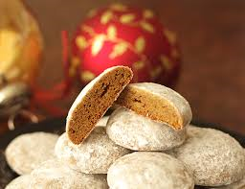
Pfeffernüsse
While the exact origin of this popular German Christmas cookie is uncertain, traditional beliefs link it to the feast of Sankt Nikolaus on December 6 in Germany. This is when children receive gifts from St. Nikolaus, who is partially the inspiration for the Santa Claus tradition. Pfeffernüsse in modern Germany, are more closely associated with Christmas. The biscuit has been part of European yuletide celebrations since the 1850s. The name pfeffernüsse peppernut) does not mean it contains nuts, though occasional varieties do.

1/2 cup molasses 1/2 tsp brown sugar
1/4 cup honey 1 1/2 tsps ground cardamom
1/4 cup shortening 1 tsp ground nutmeg
1/4 cup margarine 1 tsp ground cloves
2 eggs 1 tsp ground ginger
4 cups all-purpose flour 2 tsp anise extract
3/4 cup white sugar 2 tsp ground cinnamon
1 1/2 tsp baking soda 1 tsp ground black pepper
1/2 tsp salt 1 cup confectioners' sugar for dusting

Stir together the molasses, honey, shortening, and margarine in a saucepan over medium heat; cook and stir until creamy. Remove from heat and allow to cool to room temperature. Stir in the eggs.
Combine the flour, white sugar, brown sugar, cardamom, nutmeg, cloves, ginger, anise, cinnamon, baking soda, pepper, and salt in a large bowl. Add the molasses mixture and stir until thoroughly combines. Refrigerate at least 2 hours.
Preheat oven to 325 degrees F. Roll the dough into acorn-sized balls. Arrange on baking sheets, spacing at least 1 inch apart.
Bake in preheated oven 10 to 15 minutes. Move to a rack to cool. Dust cooled cookies with confectioners' sugar.

