Spitzbuben
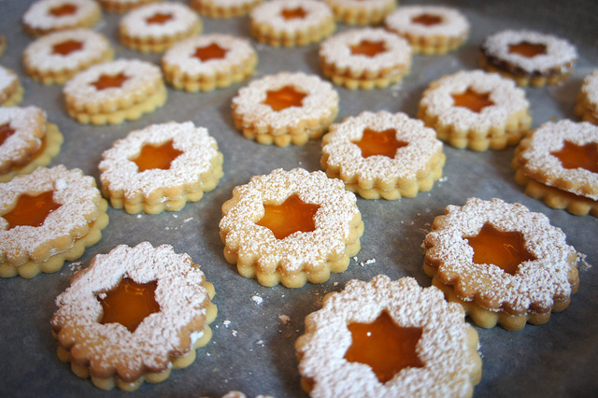
The name of this traditional Swiss sandwich cookie is Spitzbuben, which roughly translates to “little rascals.” Although typically Swiss, this cookie is also well known in Austria and Germany.

1 pinch salt 2 tsps vanilla sugar
1 egg white 1 cup confectioners' sugar
3 1/8 cups all-purpose flour 1 1/8 cups butter
1 cup fruit jam, any flavor For Vanilla Sugar: 1 ½ to 2 cups Sugar
1/3 cup powdered sugar for decoration For Vanilla Sugar: dried vanilla bean

To Make Vanilla Sugar: Combine 1 1/2 to 2 cups sugar with a rinsed and dried vanilla bean in a pint jar. Cover and shake well. Shake occasionally for 2 -3 days. Use flavored sugar, replenishing with fresh sugar, as needed.
Beat butter or margarine until soft and fluffy. Mix in the confectioners' sugar, vanilla sugar, and salt until mass has a lighter color.
Beat the egg white into the creamed mixture, making sure to incorporate fully. Add in the flour and mix. Cover the dough, and rest the dough in the refrigerator for one hour.
Take the dough out of the refrigerator, and roll it out until it is about 3/4 inch thick. Cut out circles or other shapes with pastry cutters. Cut smaller shapes into the middle of half of the shapes to use as the “sandwich tops.”
Bake in a preheated 400 degrees F (205 degrees C) oven for 6 to 8 minutes.
Warm up marmalade, apricot, or raspberry jam. Put some jam on the cookies without the holes in the middle. Then put the cookies with the holes on top of the ones with jam. Sprinkle a bit of confectioners' sugar on top to make them look nice.

