Former Hitler SS Member at Auschwitz Charged With Accessory to Murder

93-Year-Old Man Charged With at Least 300,000 Counts

By Harriet Torry

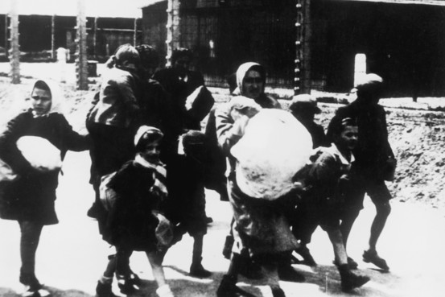
A group of women and children arriving at the Nazi concentration camp at Auschwitz, Poland, circa 1943. (Photo by Three Lions/Hulton Archive/Getty Images) Getty Images
BERLIN—Prosecutors in Germany have charged a 93-year-old man with at least 300,000 counts of accessory to murder while a member of Adolf Hitler's SS unit at the Auschwitz concentration camp.
Prosecutors accuse Oskar Gröning from Lower Saxony of having collected money from Nazi victims' luggage on their arrival at the concentration camp, which he turned over to the SS headquarters in Berlin.
"Through his activities, he provided the Nazi regime with economic advantage and supported systematic killings," the Public Attorney's Office in Hannover said in a statement. The statement alleged Mr. Gröning was aware that the camp-selection process condemned prisoners deemed unfit for work to the gas chambers.
The case comes amid a fresh push in Germany to bring aging Nazi war criminals to justice following the 2011 conviction of retired U.S. auto worker John Demjanjuk, a case which prompted a reassessment of the legal basis for proving complicity in Nazi atrocities.
While Germany has gained praise for confronting its Nazi past, historians and victims' representatives say it has a patchy record of prosecuting rank-and-file members of the Nazis' sprawling repression apparatus because of the difficulty of proving, decades later, that they committed specific crimes. Seven decades since the end of the War, the ranks of the perpetrators have thinned considerably.
Mr. Gröning has spoken publicly about his time at Auschwitz in past interviews with magazine Der Spiegel and the British Broadcasting Corp. In 2005, he told Der Spiegel of witnessing an SS soldier murder a baby during his two years as a bookkeeper at the camp in Poland. He described his role as tallying money seized from victims, most of them Jewish, but he told the magazine he didn't commit any crimes.
"Accomplice would almost be too much for me," Der Spiegel quoted him as saying in the 2005 interview. "I would describe my role as a 'small cog in the gears.' If you can describe that as guilt, then I am guilty, but not voluntarily."
Mr. Gröning's lawyer, Hans Holtermann, declined to comment on the indictment and said the relevant court in Lüneburg, Lower Saxony, hadn't formally decided yet whether to admit the case or set a date for trial. Mr. Holtermann added that his client was in good health.
The prosecutors said that based "on evidence and legal grounds," the charges relate only to a two-month period in 1944 during the Nazi occupation of Hungary. Around 1.1 million people were exterminated at the camp during the Holocaust, most of them Jews.
Until recently, prosecutions of crimes at Nazi extermination camps required a defendant be convicted of a specific murder of a specific victim—a difficult charge to prove in cases of suspected involvement in mass murder at Nazi death-camps and one factor that has limited the number of trials. An earlier investigation by prosecutors in Frankfurt into Mr. Gröning's role at the camp was dropped in 1985 due to a lack of evidence that he participated in Nazi crimes.
But the conviction of Mr. Demjanjuk for acting an accessory to the murder of nearly 30,000 people while serving as a Nazi death-camp guard opened the door to similar prosecutions. Christoph Safferling, professor of criminal law at the Philipps University of Marburg, said that case "brought a loosening of established law practice" as it interpreted the fact of having worked as a guard at an extermination camp—rather than direct involvement in the killing—as evidence of complicity in Nazi murders. The trial spurred federal officials to ask prosecutors to open probes into some 30 former Auschwitz guards still living last year.
"There is no question that [the Demjanjuk verdict] caused an incredible increase in the number of people facing prosecution," said Efraim Zuroff, chief Nazi hunter at the Simon Wiesenthal Center in Jerusalem.
Mr. Gröning's case "is very important because it's the first in recent history in which a defendant has talked [publicly] about the horrors of Auschwitz, that's something you almost never see," Mr. Zuroff said.
The Hannover prosecutors, who focus on crimes committed under the Nazi regime, said the charge follows a preliminary investigation by Germany's Central Office of the Judicial Authorities for the Investigation of National Socialist Crimes in Ludwigsburg, a federal agency that collects evidence on Nazi crimes in Germany and abroad for prosecutors.
Kurt Schrimm, who heads the special office for investigating Nazi era war crimes, said he couldn't comment on Mr. Gröning's case but said that his office spent about a year investigating identifiable Auschwitz guards before handing the case to prosecutors in Hannover in November 2013.
In its inquiry, the office in Ludwigsburg investigated a list of about 6,000 names of suspected Auschwitz guards compiled by an investigator in Frankfurt in the 1970s, Mr. Schrimm said, 49 of whom were found to be still alive. The number of living suspects had dwindled to 30 by the time Hannover prosecutors took the case, and "more have died in the meantime."
Age poses a challenge in prosecuting suspected World War II criminals. Earlier this year, a court in Ellwangen in southwest Germany declined to try suspected former guard Hans Lipschis on charges he aided the murder of 10,510 people at Auschwitz, saying the 94-year old was unfit to stand trial for health reasons.

