Name: ___________________________________________________ Datum: _______________________________ Stunde: _______
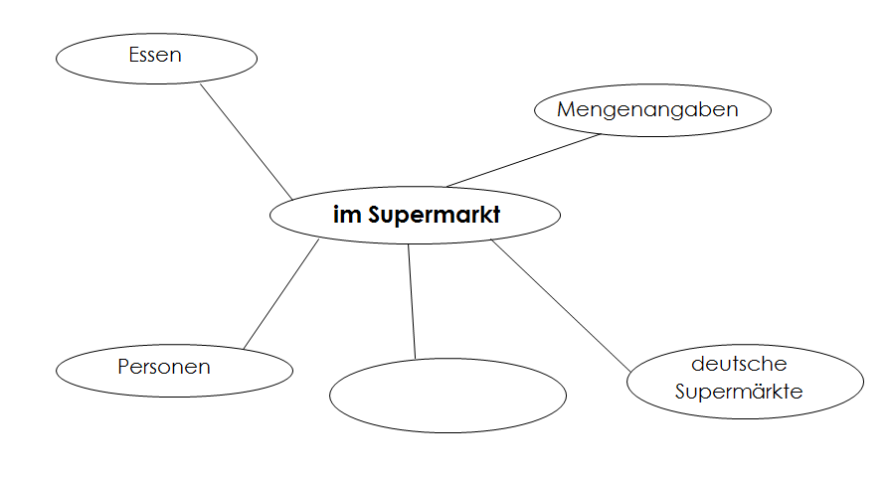
Supermarkt Mindmap

