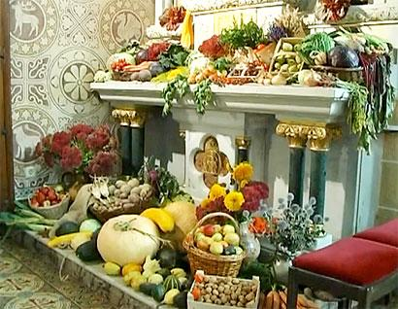
Thanksgiving Customs in Germany and the USA
In the German-speaking countries Thanksgiving is an autumn harvest celebration called Erntedank or Erntedankfest (“harvest thanksgiving festival”). The observance usually takes place in September or October. Similar harvest festivals are common in many countries and regions around the globe.

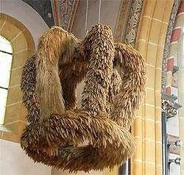
In Switzerland, many communities observe Erntedank in mid-September. In Germany the observance is often on the first Sunday in October, which is usually also the first Sunday following Michaelistag or Michaelmas (29 Sept.). This puts the Germanic thanksgiving closer to Canada’s Thanksgiving holiday in early October, rather than the American observance in late November, but there is no official date or any nationwide observance as in the US and Canada. Not even the “official” Erntedank date of the first Sunday in October, recommended by the German Catholic Church since 1972, is followed uniformly everywhere in Germany, nor is it included in the Church calendar of official observances. In some areas, Erntedank coincides with the wine harvest and takes place as late as November.

The typical German, Austrian or Swiss thanksgiving celebration (Erntedankfest) is usually a rural harvest time observance with church services, a parade, music, and a country fair atmosphere. In larger cities, Erntedankfest is sponsored by Protestant and Catholic churches. A typical German church observance begins with a sermon and perhaps some choral singing. Then comes the thanksgiving procession, complete with the presenting of the traditional “harvest crown” (Erntekrone) for the harvest queen (Erntekönigin). (Note: The queen gets a crown much smaller than the one in the photo above.). Later in the day, there’s more music, dancing, and food. In some places, there is also an evening service followed by a lantern and torch parade (Laternenumzug) for the children — and even fireworks!
Some aspects of the New World’s Thanksgiving celebration have taken root in Europe. Over the past few decades, Truthahn (turkey) has become a popular dish, widely available in German-speaking countries. The New World bird is valued for its tender, juicy meat, slowly usurping the more traditional goose (Gans) on special occasions. (And like the goose, it can be stuffed and prepared in similar fashion.) However, the Germanic Erntedankfest is still not a big day of family get-togethers and feasting like Thanksgiving in America. But like Thanksgiving, following the Erntedankfest celebration, the unused food is distributed to the needy.

There are some turkey substitutes, usually so-called Masthühnchen, or chickens bred to be fattened up for more meat. Der Kapaun is a castrated rooster that is fed until he’s heavier than the average rooster and ready for a feast. Die Poularde is the hen equivalent, a sterlilized pullet that is also fattened up (gemästet). But this is not something done just for Erntedank.

While Thanksgiving in the US is the traditional start of the Christmas shopping season, in Germany the unofficial starting date is Martinstag on November 11. (It used to be more significant as the start of 40 days of fasting before Christmas.) But things don’t really get started for Weihnachten until the first Adventsonntag (Advent Sunday) around December 1. (For more about German Christmas customs, see our Christmas pages.)

As you can tell from the above, the European thanksgiving observance is not anything like the more secular traditional family holiday and feast in Canada and the United States. Unless they live in a rural area or are church-goers, most Germans have only experienced Erntedankfest by seeing it on television. But, if you ever get a chance to personally participate in Erntedankfest in Austria, Germany or Switzerland, it will be a very enjoyable cultural experience!

http://www.german-way.com/history-and-culture/holidays-and-celebrations/thanksgiving-in-germany/
Erntedankfest Kreuzworträtsel
Instructions: Read the article on the opposite side find the keywords that match the clues below!
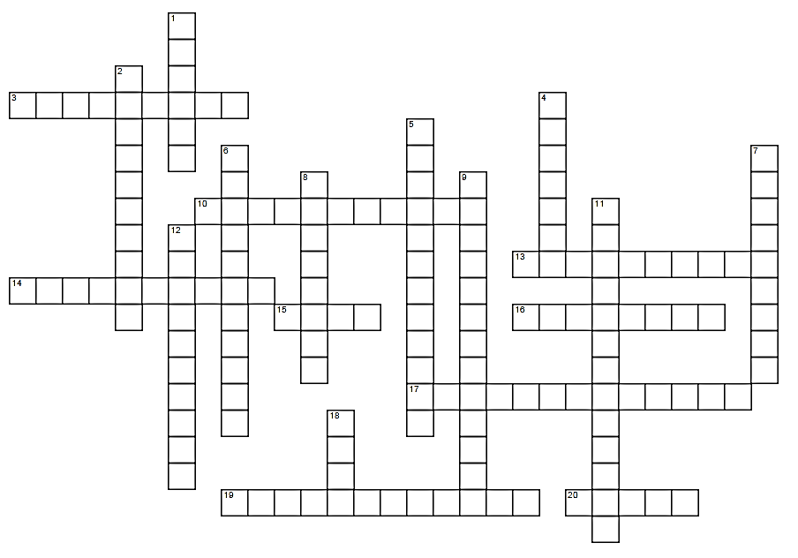
WAAGERECHT
3. Castrated rooster, fed until heavier than average and ready for the feast.
10. German Thanksgiving is not a big day family get-togethers, but unused food is _______ to the needy.
13. In Germany there is typically a procession with the presentation of this.
14. Harvest festivals are often held one week after this holiday in Germany.
15. The more traditional German Goose dish, often stuffed.
16. In larger cities, the holiday is sponsored by protestant and catholic ___________, and includes a sermon and choral singing.
17. Autumn harvest celebration most similar to Thanksgiving.
19. This “harvest queen” receives the “harvest crown” as well as a smaller crown of her own.
20. German celebrations often happen in ________ areas with church services, parades, music, and a country fair atmosphere.

SENKRECHT
1 The date of Germany’s Thanksgiving is close to this country, which is mid-October.
2 November 11th, the unofficial start of the Christmas shopping season in Germany.
4 The first Sunday in this month is when many harvest festivals are held in Germany.
5. Chickens bred to be fattened up for more meat.
6. The German word for Christmas.
7. The month in which many communities in Switzerland observe harvest festivals.
8. New world dish that has become more popular in Europe over the last few decades.
9. Around December 1st, Christmas preparations begin in earnest in Germany.
11. In some places there’s an evening service with a torch parade for children called _________ and even fireworks!
12. Unless you live in a rural area or are church-goers you are most likely to experience German Thanksgiving on the _____________!
18. German harvest celebration date is not uniform; some happen as late as November during the _______ harvest.

