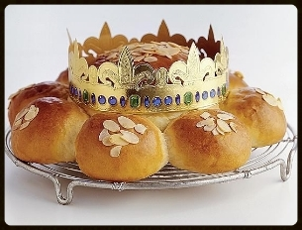
How to Make Three Kings Cake > German Three King’s Cake (Dreikonigskuchen)

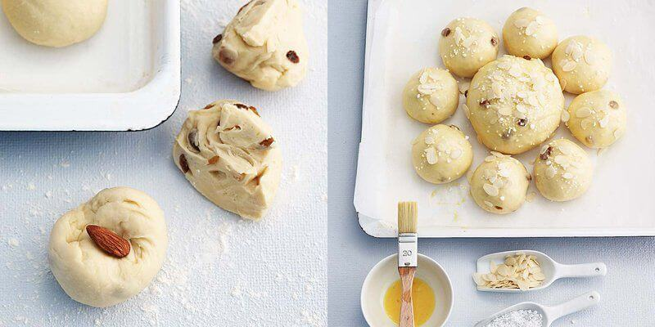
Ingredients >
2 cups + 3 tbsp flour
1.4 oz fresh yeast
1/3 cup sugar
1/4 cup + 1 tbsp lukewarm milk
7 tbsp butter or margarine, melted
1/2 tsp salt
1 chopped lemon
1/2 tsp cardamom
2 eggs, 1 separated
1/2 cup raisins, soaked in orange juice
1 cup chopped, mixed, dried fruit
Frosting >
2 tbsp powdered sugar
2 tbsp lemon juice
1/2 cup red candied cherries and , halved (optional)
Directions >
1. Put 3/4 of all flour into a bowl, make a hole in the middle, put the yeast into it and mix it with a pinch of sugar and some of the lukewarm milk. Dust the mixture with flour, cover with a cloth and let rise in a warm place for 15 minutes. Add the melted butter, salt, lemon, cardamom, egg, egg white, remaining milk and flour to the flour and yeast mixture. Knead dough till smooth.
2. When the dough begins to form a ball, stir in raisins and mixed, dried fruit. Form dough into a log. Cut off 1/4 of the log, divide the 1/4 into 4 equal parts and form balls from each. Divide the remaining log into 4 parts and form balls from each.
3. Grease well a springform pan with a central tube. Place dough into the pan, alternating large and small dough balls. Cover the pan and let rise in a warm place. Brush the dough with the beaten yolk and place in pre-heated oven (350 degrees F) for approximately 30 minutes. Cool cake thoroughly before removing from pan.
4. Mix the powdered sugar with lemon juice to an icing consistency (not too liquid). Ice the cake and decorate with the candied cherries. In Germany, a small gold crown made of foil is placed in the middle of the cake (don’t worry about that – Frau will provide the crowns!).

