UW German 103 in the High School
Enumclaw High School
Completion Information
June 2016
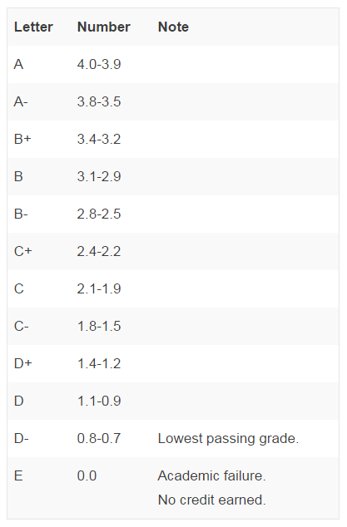
Congratulations, you have completed the UW in the HS course German 103 at Enumclaw High School! Your teacher will soon be notifying you of your official grade for the course, as well as soon submitting your grade to the University of Washington. UWHS courses are graded using the UW's numeric grading system. Grades are assigned from 0.7 to 4.0. For more information on the UW grading system and the numeric equivalent of letter grades, please see the chart below:
http://www.washington.edu/students/gencat/front/Grading_Sys.html
Student transcripts are available within one week of the course grades being submitted. Students are not automatically sent a transcript from UW after completing the course. Transcripts can be ordered online or by completing a Transcript Request Form. Students can find information on how to request their transcript on the UWHS website: http://www.uwhs.washington.edu/uwhs/credits/transcripts.asp.
You can view your final UW grade on your unofficial transcript, which is available on your MyUW account. To access your MyUW account you will first need to establish a UW NetID using your Student ID Number and Private Access Code, which were emailed to you after you registered for your course. If you need help accessing your account, visit this page: http://www.uwhs.washington.edu/registration/after.asp
If you need your UW Student Number or Private Access Code, email the UW Educational Outreach Registration Office at uweoreg@pce.uw.edu or call (206) 543-2310. To reach the UWHS Office, email uwhs@pce.uw.edu or call (206) 685-6404.
Students who later attend UW do not need to take any action to transfer the UW credits earned through the UWHS program. The credits will automatically appear on their UW student record.
Outside of UW, the UWHS program cannot guarantee that UW credits students earn will be transferrable to all colleges or universities. Many public and private institutions across the country accept UW credits earned through the UWHS program. However, there are institutions that do not accept college credit earned through dual credit programs like UWHS.
To confirm whether or not their institution will accept their UW credits, students should contact their prospective colleges or universities. Colleges or universities may consider credit transfer on a case-by-case basis, including which UW course was taken and the grade the student earned. To transfer their UW credits, students usually must order their official UW academic transcripts and send them to the college or university they will be attending.
If you have any other questions regarding UWHS please see Frau’s website at: http://frauholmquist.weebly.com/uw-103-information.html or contact Frau at: alysha_holmquist@enumclaw.wednet.edu
Danke!

