Name: _________________________________ Datum: ____________________ Stunde: ________
Rick Steves Europe: Vienna
We’ll be visiting this amazing city! Watch the video: Rick Steves Vienna and answer the questions below.

1. What do German-speaking “locals” call Vienna? __________________________________
2. Which three things can you get at Café Demel? (check all boxes that apply)
□ Apple Strudel □ Cookies □ Sacher Torte □ Chocolate □ Gummy Bears
3. St. Stephan’s Cathedral (Stephansdom) was heavily damaged during which war? _____
_____________________________________________________________________________________
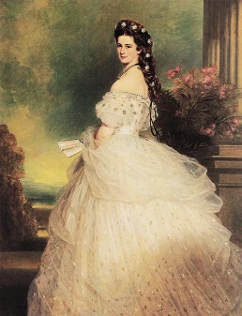
4. What colors (in German) are the classic Viennese tram cars?
__________________________________________________________________
5. What is the name of the famous river that runs through Vienna?
__________________________________________________________________
6. Schönbrunn Palace is where the Hapsburg family ruled Vienna for many years. One of the most famous of this family (pictured here) was _______________________, who was known for her obsession with beauty and dieting.
7. The Naschmarkt (a famous produce market) was created about ___________ years ago.
8. The German word “Kraut” means _________________________________________________.
9. A statue of ________________________________, a famous Austrian composer, can be found in Vienna’s city park.
10. The _________________________________ is a very famous dance originating in Vienna.
11. CHROMEBOOK: Go to www.lonelyplanet.com/austria/vienna ... What three things are you looking forward to the most?
1. ___________________________________________________________
2. ___________________________________________________________
3. ___________________________________________________________

