Name: ___________________________________ Datum: ____________________ Stunde: ______

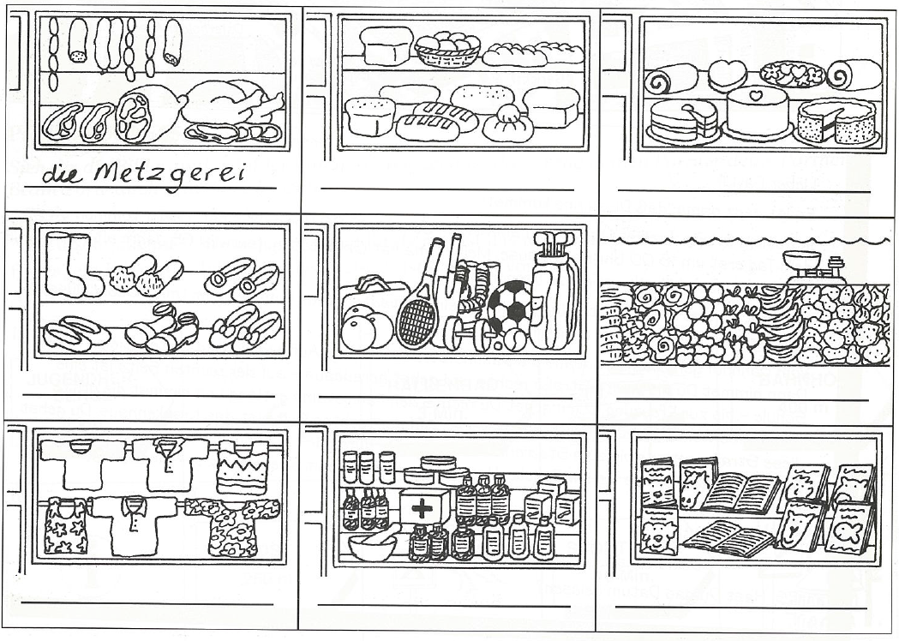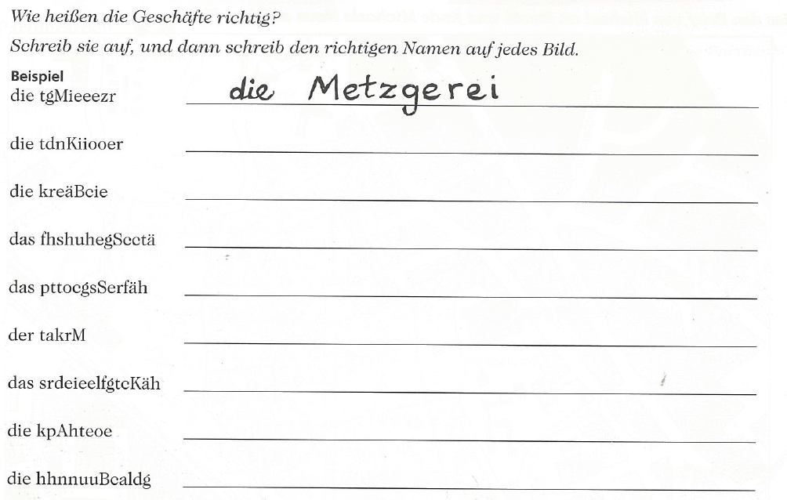**Wie heisst das Geschäft?**

**Wie heissen die Geschäfte richtig?** Unscramble the store names below and match them to the pictures.

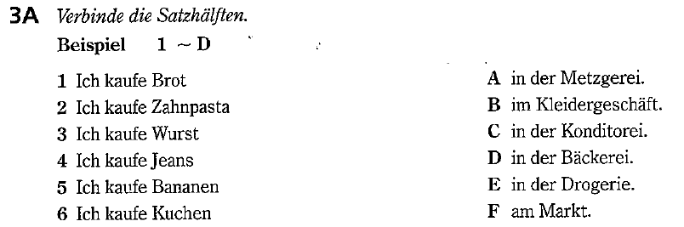

**Wo kauft man das?** Match the product to where one can buy it.

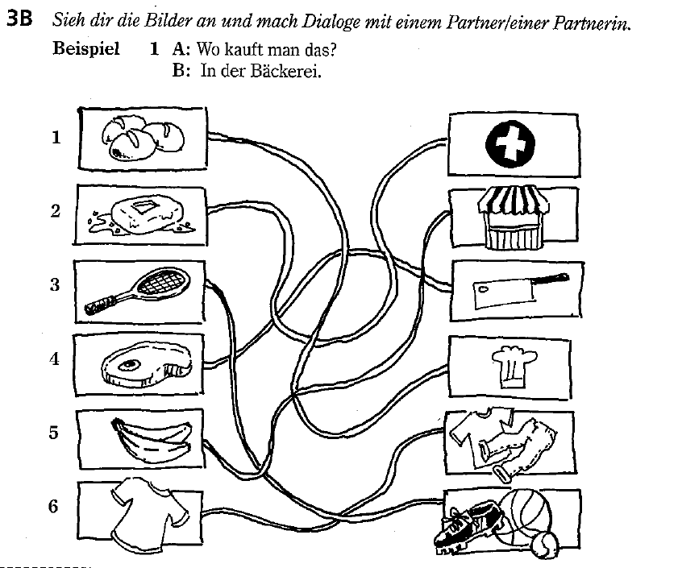

**Wo kann man das kaufen?** Match the product to where one can buy it. Then write out the complete sentence below.

**1. ___________________________________________________________________________**

**2. ___________________________________________________________________________**

**3. ___________________________________________________________________________**

**4. ___________________________________________________________________________**

**5. ___________________________________________________________________________**

**6. ___________________________________________________________________________**

**___________________________________________________________________________**