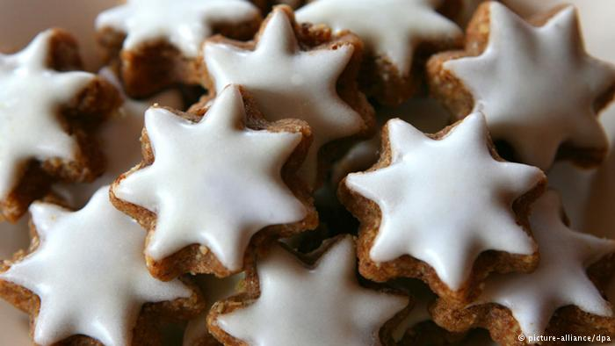
Zimtsterne
The festive season in Germany brings with it a veritable galaxy of stars - cinnamon stars that is. Germans love a sweet treat at Christmas, especially the aromatic Zimtsterne. They're a popular type of Christmas cookie in Germany. Taking the German word for cinnamon (Zimt) and Stern, meaning star, traditional Zimtsterne are made from ground nuts - usually almonds or hazelnuts -, powdered sugar and of course a generous sprinkling of cinnamon. The delicious Christmas cookies can be sourced in supermarkets or at Chirstmas markets across Germany, but it's much more fun to make your own!

Use star shaped cookie cutters about 1 1/2 to 2 inches across. Yes… you can use circles or snowmen or palm trees… but then they wouldn’t be cinnamon STARS, would they?
Ingredients
- 3 Egg Whites
- 2 cups 250 g Powdered sugar
- 1-2 Tbl. Ground Cinnamon (to taste... maybe start with 1...these can get strong)
- 1 Tbl. Fresh Lemon Zest
- 3 cups/ 300g Ground Almonds
- IN ADDITION
- loads of Powdered Suger
Instructions
- Preheat oven to 325 degrees Fahrenheit.
- In a Mixer... whip up those egg whites... add powdered sugar ...slowly (or you'll get it up your nose). It'll be thickish, and a little goopy looking.
- Take out 8 Tablespoons of the egg white/sugar mix, and put it in a plastic baggie or piping bag. Set aside.
- In a small bowl, combine the ground almonds, cinnamon and lemon zest.
- Add the Almond Mix to the Egg White Mix.... Use a wooden spoon to stir it together until it is fully
- combined.
- Let it rest for 15 minutes (you can rest for those 15 too... read a magazine or something).
- Time's UP!
- Ok... prepare your rolling out surface by covering it with a thick layer of powdered sugar.
- Rub your rolling pin with powdered sugar.
- Grab a chunk of the dough... with powder sugar hands.... and pat it into a disk. Set it on the powdered sugar... rub it into the sugar... flip and rub again... Now start rolling.
- Remember... you are rolling out dough, not trying to permanently meld the almonds into the kitchen counter. Roll easy. Flip it or rotate the dough often. If it starts to stick... hit it with more powdered sugar.
- You want to roll it about 1/3 inch (.5cm) thick. No... you don't need to get out the ruler.... just eyeball it. It's cookies, not brain surgery.
- Cut the cookies out with a star shaped cutter. If the cutter feels sticky... dip it in powdered sugar (are you seeing a pattern?)
- Put the cut out cookies on a cookie sheet.... you can put the cookies fairly close together since they don't spread.
- Gather the dough scraps... add some new dough to it... and roll again. Keep going until the dough is used up.
- When you have a full tray.....
- Clip the corner of the baggie containing the bit of meringue and pipe it onto the cookies. Don't let it drip over the side.
- Bake for 15 minutes.
- Let them cool on the baking sheet.
- Eat.
Notes
I find these taste better after a day or two. You can store these cookies air tight in a dark space for a few weeks.

