Name: ___________________________________ Datum: ____________________ Stunde: ______

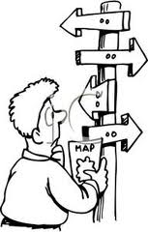
ZZN2 Kapitel 1 Review (Selbstbedienung)

Complete the following exercises as review for the Kapitel 1 Test. You will need to use pages 12-13 in your textbook. You may aslo use previous materials, your text book (pages 6 -15), and vokabelkarten. Be sure to read the instructions carefully!

- Strassenschilder: Sieh dir die Strassenschilder an, und lies die Sätze. Ist das richtig oder falsch? Look at the street signs – are they richtig (R) oder falsch(F)? If the signs are falsch, correct the sentence. (5P)
STADION
DOM

- ______ Die Stadthalle ist links.
STADTHALLE
- ______ Der Dom ist rechts.
MUSEUM 300m
- ______ Das Stadion ist geradeaus.
SCHWIMMBAD
SCHLOSS
RATHAUS
- ______ Das Museum ist 300 Meter rechts.
- ______ Das Schloß ist geradeaus.

- Und deine Stadt? Lies den Brief und beantworte die Fragen. Read the letter from Andreas to Tom and answer the questions at the bottom of page 12 in complete sentences . (10P)

- ______________________________________________________________________________
- ______________________________________________________________________________
- ______________________________________________________________________________
- ______________________________________________________________________________
- ______________________________________________________________________________
- Lieber Andreas! Schreib den Brief – ersetz die Bilder mit den passenden Wörtern. Read the letter from Tom to Andreas. Write out the whole letter in German. Replace the pictures with words from the box below. Underline the words you’ve replaced. (5P)
Jugendzentrum Kinos ein Rathaus eine Stadthalle
ein Schwimmbad einen Dom das Verkehrsamt einen Campingplatz
ein Sportzentrum

Lieber _________________________,
_____________________________________________________________________________________
_____________________________________________________________________________________
_____________________________________________________________________________________
_____________________________________________________________________________________
_____________________________________________________________________________________
_______________________________________

Dein _______________________

- Was kann man hier machen? Was sagt der Tourist im Verkehrsamt? What does the tourist in the city information office say? Look at the pictures in the book and choose from the words below. Write in complete sentences. (6P)
ein Poster? einen Stadtplan? einen Prospekt über Konzerte?
eine Hotelliste? eine Broschüre? einen Prospekt über Ausflüge?

- __________________________________________________________________________?
- __________________________________________________________________________?
- __________________________________________________________________________?
- __________________________________________________________________________?
- __________________________________________________________________________.
- __________________________________________________________________________.
- Halb und halb. Wie sind die Sätze richtig? Match the sentences halves below. Write out the whole sentence on each line below. (7P)

- Hier ist gar… a. …mir gut hier.
- Es gefällt… b. …gern in Braunau.
- Ich wohne nicht… c. …nichts los!
- Es gibt zuviel… d. …genug Jugendzentren.
- Es gibt nicht… e. …dein Dorf?
- Wie findest du… f. …Rauch und zu viele Autos.
- Die Stadt ist… g. …ganz ruhig und sauber.

- ___________________________________________________________________________
- ___________________________________________________________________________
- ___________________________________________________________________________
- ___________________________________________________________________________
- ___________________________________________________________________________
- ___________________________________________________________________________
- ___________________________________________________________________________
- Was ist das? Schreib das richtige Wort. Choose a word from the box below and write it beneath the corresponding picture. Change the der/die/das to ein/eine/ein! (11P)
das Verkehrsamt das Stadion der Zoo das Schloss
die Fussgängerzone der Bahnhof das Rathaus der Dom
das Jugendzentrum der Tennisplatz das Museum der Campingplatz
das Schwimmbad das Kino die Stadthalle die Post

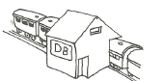
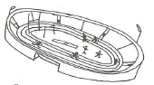
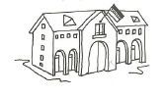
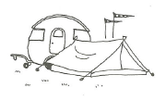
- . 2. 3. 4.

ein Stadion

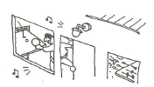
___________________ ___________________ ___________________ ___________________
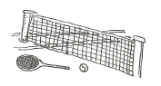
5. . 6. 7. 8.

___________________ ___________________ ___________________ ___________________

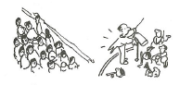
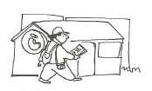
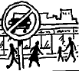
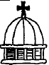
9. 10. 11. 12.

___________________ ___________________ ___________________ ___________________

- Wie heisst das Wort? Unscrabmble the discriptive word below and write the correct word on the line. (5P)

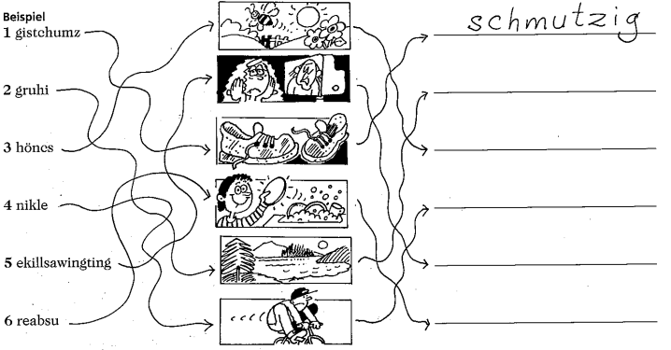

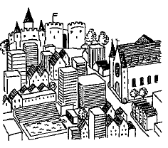
- Meine Stadt: You live in the towns pictured below. Is it a city or village? Tell what there is in each city (Es gibt einen/eine/ein), what the atmostphere is like (clean? quiet? etc) and any other physical conditions of the town. (5P)











